**CW Machine Window**

# Geoff Anderson G3NPA, Hew Lines VA7HU and Aki Yoshida JA1NLX

## 1.0 GENERAL

The CW Machine provides the capability to interface Logger32 to your transceiver and to send CW from Logger32 via a serial or parallel port interface. It is fully customizable and consists of a transmit buffer window and up to 36 user-programmable buttons that may be displayed in groups of  0, 12, 24 or 36. Each button may be programmed using Macro language statements and/or text and may be colored and labeled. Using your imagination and the Macro language, you can create single-button functionality which will make operating CW more enjoyable and easier.

The CW Machine is basically a software keyer but it will also support the use of a WinKey1 or 2 CW keyer.

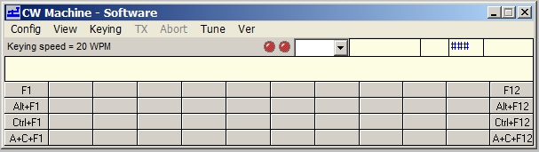

CWM_1

**Note:**

If the CW Machine is running when WSJT/JTDX is started, the CW Machine close automatically..  If, while running WSJT/JTDX a CW DX Spot is clicked, when WSJT/JTDX is closed, the CW Machine open automatically.

If WSJT/JTDX are running and user wish to switch, simply click on the CW Machine picture on the ToolBar and WSJT/JTDX will close and the CW Machine will open.

## 2.0 MAIN MENU